Marketing Mobility as a Service: Insights from the National Household Travel Survey

Cassidy Crossland
ORCiD: 0000-0001-7096-5615
Department of Civil and Environmental Engineering
University of Tennessee
325 John D. Tickle Building
851 Neyland Drive
Knoxville, Tennessee, 37996-2313
Email: ccrossl3@utk.edu

Candace Brakewood, PhD
ORCiD: 0000-0003-2769-7808
Department of Civil and Environmental Engineering
University of Tennessee
325 John D. Tickle Building
851 Neyland Drive
Knoxville, Tennessee, 37996-2313
Email: cbrakewo@utk.edu

Word Count: 5,793 words + 6 tables (250 words per table) = 7,293 words

FUNDING STATEMENT
This research was funded in part by by the Tennessee Department of Transportation (TDOT) grant RES2020-20 entitled "Investigating the Service of App-Based Rideshare and Transportation Network Companies in Tennessee" and by the Dwight David Eisenhower Transportation Fellowship Program (DDETFP) Graduate Fellowship from the U.S. Department of Transportation Federal Highway Administration (FHWA).

DATA ACCESSIBILITY STATEMENT
The dataset is from the 2017 National Household Travel Survey found at the National Household Travel Survey website (https://nhts.ornl.gov/).

ABSTRACT
The concept of Mobility as a Service (MaaS) is relatively new in transportation. MaaS provides travelers with bundles of transportation services that can be purchased together rather than relying on individually-owned transportation modes. Although MaaS is begin to grow in popularity, few if any prior studies have focused on the demographics of existing or potential MaaS users with a goal of targeting specific markets. Therefore, the objective of this paper is to evaluate potential shared transportation bundles that could be marketed as MaaS in the United States using the 2017 National Household Travel Survey (NHTS). The 2017 NHTS asked questions about usage of five shared transportation modes: bikeshare, carshare, online delivery services, rideshare, and public transit. Various shared transportation bundles were created using these shared transportation mode questions. For each shared transportation bundle, three binary logit models were run: one for those who live in urban areas, one for those who live in rural areas, and one nationwide. In total, 12 shared transportation bundles were evaluated for this paper, resulting in 36 models. While most of the models had similar trends, such as each bundle being used by those with fewer vehicles, there were key differences between urban and rural areas for each bundle, including gender and income level. By understanding the demographic trends of potential MaaS users, marketing can be targeted toward the people who are most likely to use MaaS in the future.

Keywords: Mobility as a Service, NHTS, Ridesharing, Delivery, Public Transit, Bikeshare, Carshare
INTRODUCTION
Mobility as a Service (MaaS) is a new and growing transportation concept. MaaS allows users to plan trips and pay for various transportation services to them in one place. One characteristic of MaaS is that users can typically purchase a bundle, or group, of transportation services in one transaction. This could include access to different shared transportation modes such as carshare, bikeshare, and ridehailing. Shaheen and Cohen have presented definitions for these shared modes for unfamiliar readers (1).
The first implementations of MaaS began within in the past ten years (2). As of 2017, 12 cities from around the world had piloted MaaS trials including Helsinki, Vienna, Singapore, and Barcelona (3). As MaaS applications continue to grow in availability and popularity, it will not be surprising to see more trials implemented around the world.
While there have been a few simplified versions of MaaS in the United States (US), including Denver, Las Vegas, and Los Angeles, it is still not commonplace (3). To plan for future implementations, there is a need to create shared transportation bundles to be marketed as packages in MaaS trials. The 2017 National Household Travel Survey (NHTS) asked questions about five modes of shared transportation that could be part of MaaS packages: bikeshare, carshare, online delivery services, rideshare, and public transit. The aim of this study is to use the 2017 NHTS to evaluate shared transportation bundles and demographic trends for different potential bundles based on the people already using individual modes. By understanding the demographic trends of potential MaaS users, marketing can be targeted toward the people who are most likely to use MaaS in the future.
The paper is organized as follows: the literature review consisting of two parts, Mobility as a Service and the 2017 National Household Travel Survey, followed by a description of the data and method of analysis. The results section consists of four parts, one for each of the selected bundles, which is followed by the discussion, areas for future research, and conclusions.

LITERATURE REVIEW
This section discusses previous literature related to this study. There are two subsections in the literature review: studies that are related to MaaS and studies using the 2017 NHTS shared transportation mode questions. Within the MaaS subsection, studies are grouped into two sections: international experiences and US studies.

Mobility as a Service
Even though MaaS is a relatively new concept, a number of international studies have been completed. In a small number of places outside of the US, MaaS is already a reality and user experience surveys provide data that can be evaluated to better understand MaaS. In the US, MaaS is still largely theoretical and, therefore, the research is more conceptual.

International Experience
Several studies in Europe and Australia conducted actual and potential user surveys to better understand MaaS. First, a trial using transport service broker UbiGo in Gothenburg, Sweden, included pre-, during, and post-trial surveys and interviews of 195 participants (4). Participants concluded that they were able to better manage their tickets and bookings thanks to a smartphone application; used a greater number of transportation modes several of which they had not used before; and reduced overall travel costs. Participants also started trying other new services not included in the UbiGo trial such as grocery delivery services.
Two additional studies analyzed surveys to understand potential user perceptions of MaaS. First, a study that used data from the 2018 Swiss Household Energy Demand Survey (N = 995 respondents) found respondents who were already using public transit were more open to using MaaS than those who relied on personal vehicles (5). The respondents perceived MaaS as an additional public transportation option rather than a new mobility concept.In suburban Sydney, Australia, 252 computer assisted interviews were completed by residents between March 23 and April 7, 2017 (6). The results of these interviews revealed that people who used their cars 2 to 4 days a week were more likely to use MaaS than those who used their cars more or less frequently. MaaS plans with taxi and ridesharing add-ons were perceived favorably, specifically for people who were already using those services. Additionally, households with two or more children were less likely to use MaaS.

US Context
Researchers in the US have looked at MaaS and other similar concepts. Shaheen and collaborators have researched Mobility on Demand (MOD) (1, 7-16). In USDOT Report Mobility on Demand: Concept Report, Shaheen et al. discussed the difference between MaaS and MOD. MaaS “…emphasizes mobility aggregation, smartphone and app-based subscription access, and multimodal integration” whereas MOD allows consumers to “… access mobility, goods, and services on demand by dispatching or using shared mobility, courier services, UAVs, and public transportation solutions” (11). In the same report, Shaheen et al. found that in urban areas, MOD would best be used for first- and last-mile connections, movement of goods within the urban area, commuting, and trips for those with special needs. It was noted that MOD services could help with public transportation issues such as reducing peak period congestion and providing transportation modes outside of public transportation service hours. In rural areas, Shaheen et al. found that MOD could be used to access resource-based jobs, trips for people with unique needs (including older people, people with lower incomes, people without cars, and people with disabilities), and trips to and from the airport (11).

2017 NHTS
At least five prior studies examined different shared transportation modes from the 2017 NHTS. Four of the five studies focused specifically on data relating to ridesharing. Jiao et al. looked at the difference between weekday and weekend trip generation and found that ridesharing increased number of trips made (17). Two studies looked at the demographic characteristics of ridesharing users (18, 19). Deka and Fei found people used ridesharing more frequently in areas with higher populations (18). Sikder found people in urban areas and those who use bikeshare and carshare were more likely to use ridesharing (19). Mitra et al. focused on ridesharing use among the elderly population and found that the younger group of the elderly population was most likely to adopt, even if they did not use the services frequently (20). Zhang and Zhang looked at the relationship between public transit use and bikesharing trips and found that people in highly populated areas with rail service are more likely to use bikesharing (21).

Gaps in the Research
To the best of the authors’ knowledge, there have not been any studies that looked at the demographics for people using multiple shared transportation modes from the 2017 NHTS. Another aspect of the 2017 NHTS that has not been thoroughly studied is the difference in shared transportation mode use between those in urban and rural areas. This study begins to address these gaps.

DATA AND METHODOLOGY
This section discusses the data and methodology. The three subsections delineate the data collection and survey content, variable selection and creation, and the model framework.

Data Background and Collection
The 2017 NHTS data consists of four datasets: household, person, vehicle, and trip. These datasets, along with the NHTS codebook, were downloaded from the NHTS website (22). The NHTS took 14 months to collect all responses beginning March 31, 2016, and ending May 8, 2017 (23). The survey was given in two parts, the first being the Household Recruitment Survey and the second being the Retrieval Questionnaire. The Household Recruitment Survey was filled out by a single member of the household while the Retrieval Questionnaire required responses from all members of the household. The questions from the two-phase survey were downloaded from the Recruitment Survey and the Retrieval Questionnaire files.

Variable Selection and Creation
Five questions regarding shared transportation mode use over the past month in the Retrieval Questionnaire were used to create the shared transportation bundles in this study: bikeshare, carshare, online delivery, rideshare, and public transit. Figure 1 shows each question, as well as the reason a question was not asked of the respondent (resulting in an appropriate skip), number of responses excluding the appropriate skips, and potential answers along with the number of respondents and percentage of each response for the five quesitons. The potential responses were condensed in Figure 1. For the column Have used 1+times in the past 30 days refers to any response that provided a number greater than zero. The column Haven’t used in the past 30 days refers to any response that answered the question with zero. The column I don’t know or I prefer not to answer refers to the total number of responses for the answer I don’t know and the total number of responses for the answer I prefer not to answer.
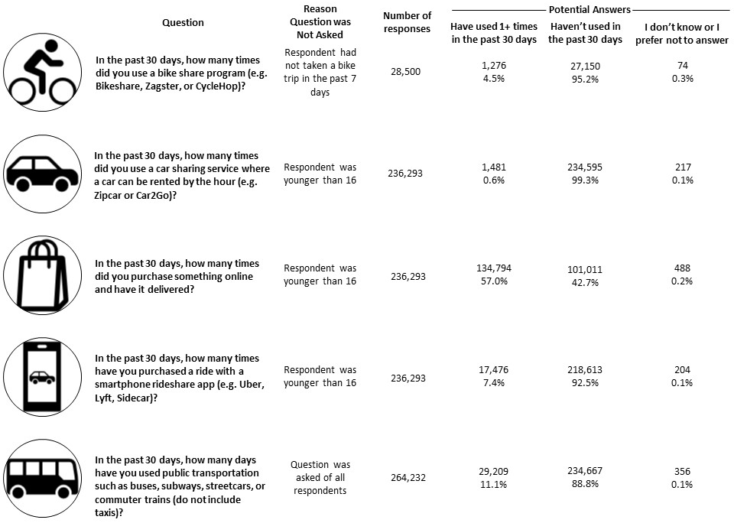
FIGURE 1 Questions from the 2017 NHTS Retrieval Questionnaire (24)
Creating Shared Transportation Bundles
Several variables were created from these five questions for bikeshare (B), carshare (C), online delivery (D), rideshare (R), and public transit (T), and these were used as the dependent variables in the multivariate analysis that follows. These variables were created to see if there were different demographic trends among people who use different combinations of modes. The variable was formulated as a binary variable (1 = used all services in the bundle; 0 = did not use all services in the bundle). Ten variables were created for people who used two modes of transportation (BC, BD, BR, BT, CD, CR, CT, DR, DT, and RT). Ten additional variables were created for people who used three modes of transportation (BCD, BCR, BCT, BDR, BDT, BRT, CDR, CDT, CRT, and DRT). Five variables were created for people who used four modes of transportation (BCDR, BCDT, BCRT, BDRT, and CDRT). A single final variable was created for people who used all five of the modes of transportation (BCDRT).

Independent Variables
Using the NHTS 2017 codebook, several demographic variables were selected from the person dataset and used as the independent variables in the multivariate analysis that follows. These variables included imputed age, imputed gender, race, Hispanic origin, educational attainment, employment status, medical condition making it difficult to travel outside of the home, annual household income, household size, number of household vehicles, and residential area type. Imputed age and gender are provided by the NHTS when certain answers were left blank, including age and gender, and put into the NHTS dataset as separate variables. Cross tabulations were run to compare the responses for both age and gender compared to the imputed age and gender, and there was little change between the two. The imputed age and gender were selected to keep the dataset as large as possible. The residential area variable became an additional way to further refine the results and determine if there were differences in trends for those who lived in urban areas as opposed to rural areas. Of the 264,234 responses, 202,907 (76.8%) of respondents resided in urban areas while 61,327 (23.2%) resided in rural areas.

Binary Logit Models
Thirty-six binary logit models were created using STATA 16. Three models were run for each of the shared transportation bundles selected (one for those in urban areas, one for those in rural areas, and one nationwide). As previously stated, the shared transportation bundles became binary variables. The variables had values of zero for those who did not use the shared transportation bundles and one for anyone who used all of the transportation modes in the bundle, regardless of frequency of use.
In these models, household size and number of household vehicles were the only continuous independent variables, ranging from one to thirteen and zero to twelve, respectively. All remaining independent variables were binary; when the respondent fell into a given category, the value was set equal to one. For all categories that used binary variables, a reference variable was defined and then used when interpreting the coefficients. The data used in the models excludes the non-response entries and does not include the weights.

RESULTS
Shared Transportation Bundles
Table 1 shows the sample size of the shared transportation bundles broken up by residential location (unweighted). It was created to facilitate selection of preferred shared transportation bundles. This table provides information on the numbers and percentages of survey respondents who use each of the shared transportation bundles. This was done for the three samples sizes: respondents living in urban areas, respondents living in rural areas, and the entire dataset. Models were then run for variables that had at least 1% of their sample using those services. This resulted in 12 different shared transportation bundles, indicated in bold and italics in Table 1: BD, BR, BT, DR, DT, RT, BDR, BDT, BRT, DRT, BDRT, and BCDRT.

TABLE 1 Sample Size and Percent of Users of Shared Transportation Bundles by Residential Location (Unweighted)
 | Does Not Use the Service(s) |  |  |  |  |  | Uses the Service(s) |  |  |  |  |  | Total
 | Urban |  | Rural |  | Nationwide |  | Urban |  | Rural |  | Nationwide |  | Urban |  | Rural |  | Nationwide
 | Count | % | Count | % | Count | % | Count | % | Count | % | Count | % | Count | %* | Count | %^ | Count | %~
B | 21,964 | 95.28 | 5,186 | 96.48 | 27,150 | 95.51 | 1,087 | 4.72 | 189 | 3.52 | 1,276 | 4.49 | 23,051 | 11.36 | 5,375 | 8.76 | 28,426 | 10.76
C | 179,365 | 99.26 | 55,230 | 99.74 | 234,595 | 99.37 | 1,335 | 0.74 | 146 | 0.26 | 1,481 | 0.63 | 180,700 | 89.06 | 55,376 | 90.30 | 236,076 | 89.34
D | 75,184 | 41.65 | 25,827 | 46.70 | 101,011 | 42.84 | 105,313 | 58.35 | 29,481 | 53.30 | 134,794 | 57.16 | 180,497 | 88.96 | 55,308 | 90.19 | 235,805 | 89.24
R | 164,376 | 90.96 | 54,237 | 97.95 | 218,613 | 92.60 | 16,340 | 9.04 | 1,136 | 2.05 | 17,476 | 7.40 | 180,716 | 89.06 | 55,373 | 90.29 | 236,089 | 89.35
T | 176,868 | 87.24 | 57,799 | 94.37 | 234,667 | 88.93 | 25,868 | 12.76 | 3,451 | 5.63 | 29,209 | 11.07 | 202,736 | 99.92 | 61,250 | 99.87 | 263,876 | 99.86
BC | 15,140 | 99.41 | 3,152 | 99.59 | 18,292 | 99.44 | 90 | 0.59 | 13 | 0.41 | 103 | 0.56 | 15,230 | 7.51 | 3,165 | 5.16 | 18,395 | 6.96
BD | 14,608 | 96.00 | 3,076 | 97.25 | 17,684 | 96.21 | 609 | 4.00 | 87 | 2.75 | 696 | 3.79 | 15,217 | 7.50 | 3,163 | 5.16 | 18,380 | 6.96
BR | 14,941 | 98.09 | 3,151 | 99.53 | 18,092 | 98.34 | 291 | 1.91 | 15 | 0.47 | 306 | 1.66 | 15,232 | 7.51 | 3,166 | 5.16 | 18,398 | 6.96
BT | 22,623 | 98.21 | 5,333 | 99.29 | 27,956 | 98.42 | 412 | 1.79 | 38 | 0.71 | 450 | 1.58 | 23,035 | 11.35 | 5,371 | 8.76 | 28,406 | 10.75
CD | 179,414 | 99.46 | 55,192 | 99.83 | 234,606 | 99.54 | 983 | 0.54 | 95 | 0.17 | 1,078 | 0.46 | 180,397 | 88.91 | 55,287 | 90.15 | 235,684 | 89.20
CR | 179,973 | 99.62 | 55,308 | 99.90 | 235,281 | 99.69 | 688 | 0.38 | 53 | 0.10 | 741 | 0.31 | 180,661 | 89.04 | 55,361 | 90.27 | 236,022 | 89.32
CT | 180,015 | 99.64 | 55,319 | 99.92 | 235,334 | 99.71 | 646 | 0.36 | 42 | 0.08 | 688 | 0.29 | 180,661 | 89.04 | 55,361 | 90.27 | 236,022 | 89.32
DR | 166,596 | 92.34 | 54,339 | 98.29 | 220,935 | 93.74 | 13,817 | 7.66 | 947 | 1.71 | 14,764 | 6.26 | 180,413 | 88.91 | 55,286 | 90.15 | 235,699 | 89.20
DT | 166,119 | 92.13 | 53,756 | 97.28 | 219,875 | 93.34 | 14,190 | 7.87 | 1,502 | 2.72 | 15,692 | 6.66 | 180,309 | 88.86 | 55,258 | 90.10 | 235,567 | 89.15
RT | 147,497 | 96.05 | 54,987 | 99.39 | 229,484 | 97.29 | 6,059 | 3.95 | 340 | 0.61 | 6,399 | 2.71 | 153,556 | 75.68 | 55,327 | 90.22 | 235,883 | 89.27
BCD | 15,138 | 99.52 | 3,153 | 99.75 | 18,291 | 99.56 | 73 | 0.48 | 8 | 0.25 | 81 | 0.44 | 15,211 | 7.50 | 3,161 | 5.15 | 18,372 | 6.95
BCR | 15,153 | 99.51 | 3,156 | 99.72 | 18,309 | 99.55 | 74 | 0.49 | 9 | 0.28 | 83 | 0.45 | 15,227 | 7.50 | 3,165 | 5.16 | 18,392 | 6.96
BCT | 15,153 | 99.57 | 3,155 | 99.72 | 18,308 | 99.59 | 66 | 0.43 | 9 | 0.28 | 75 | 0.41 | 15,219 | 7.50 | 3,164 | 5.16 | 18,383 | 6.96
BDR | 14,959 | 98.33 | 3,150 | 99.62 | 18,109 | 98.55 | 254 | 1.67 | 12 | 0.38 | 266 | 1.45 | 15,213 | 7.50 | 3,162 | 5.16 | 18,375 | 6.95
BDT | 14,920 | 98.13 | 3,141 | 99.37 | 18,061 | 98.34 | 285 | 1.87 | 20 | 0.63 | 305 | 1.66 | 15,205 | 7.49 | 3,161 | 5.15 | 18,366 | 6.95
BRT | 15,022 | 98.69 | 3,153 | 99.62 | 18,175 | 98.85 | 199 | 1.31 | 12 | 0.38 | 211 | 1.15 | 15,221 | 7.50 | 3,165 | 5.16 | 18,386 | 6.96
CDR | 179,763 | 99.67 | 55,239 | 99.94 | 235,002 | 99.73 | 597 | 0.33 | 35 | 0.06 | 632 | 0.27 | 180,360 | 88.89 | 55,274 | 90.13 | 235,634 | 89.18
CDT | 179,746 | 99.73 | 55,214 | 99.95 | 234,960 | 99.78 | 494 | 0.27 | 29 | 0.05 | 523 | 0.22 | 180,240 | 88.83 | 55,243 | 90.08 | 235,483 | 89.12
CRT | 180,088 | 99.77 | 55,294 | 99.96 | 235,382 | 99.81 | 414 | 0.23 | 23 | 0.04 | 437 | 0.19 | 180,502 | 88.96 | 55,317 | 90.20 | 235,819 | 89.25
DRT | 175,114 | 97.15 | 54,947 | 99.47 | 230,061 | 97.69 | 5,145 | 2.85 | 294 | 0.53 | 5,439 | 2.31 | 180,259 | 88.84 | 55,241 | 90.08 | 235,500 | 89.13
BCDR | 15,147 | 99.60 | 3,154 | 99.78 | 18,301 | 99.63 | 61 | 0.40 | 7 | 0.22 | 68 | 0.37 | 15,208 | 7.50 | 3,161 | 5.15 | 18,369 | 6.95
BCDT | 15,143 | 99.63 | 3,153 | 99.78 | 18,296 | 99.65 | 57 | 0.38 | 7 | 0.22 | 64 | 0.35 | 15,200 | 7.49 | 3,160 | 5.15 | 18,360 | 6.95
BCRT | 15,160 | 99.63 | 3,156 | 99.75 | 18,316 | 99.65 | 56 | 0.37 | 8 | 0.25 | 64 | 0.35 | 15,216 | 7.50 | 3,164 | 5.16 | 18,380 | 6.96
BDRT | 15,023 | 98.82 | 3,150 | 99.65 | 18,169 | 98.98 | 179 | 1.18 | 11 | 0.35 | 188 | 1.02 | 15,202 | 7.49 | 3,161 | 5.15 | 18,357 | 6.95
CDRT | 179,847 | 99.80 | 55,213 | 99.97 | 235,060 | 99.84 | 360 | 0.20 | 18 | 0.03 | 378 | 0.16 | 180,207 | 88.81 | 55,231 | 90.06 | 235,438 | 89.10
BCDRT | 15,149 | 99.68 | 3,153 | 99.78 | 18,302 | 99.70 | 48 | 0.32 | 7 | 0.22 | 55 | 0.30 | 15,197 | 7.49 | 3,160 | 5.15 | 18,357 | 6.95
Where B=Bikeshare, C=Carshare, D=Online Delivery Services, R=Rideshare, T=Public Transit, * N=202,907, ^ N=61,327, ~ N=264,234, Bold/Italics=models that were run

Comparison and Selection of Preferred Models
Thirty-six models were run across the three sample sizes. To compare the models, a table of the Pseudo-R² values was created. As seen in Table 2, the models were sorted from highest goodness of fit to lowest for Urban, Rural, and Nationwide. Across the three sample areas, the top three models in terms of goodness of fit were the same with online delivery and rideshare (DR) being the highest; followed by online delivery, rideshare, and public transit (DRT); and finally rideshare and public transit (RT). For both the urban area and nationwide, the next highest goodness of fit was all five modes of transportation (BCDRT). These four models, which are shaded in Table 2, are the focus of the results section that follows.

TABLE 2 Comparison of Pseudo R-Squared Values for Shared Transportation Bundles by Residential Location
Urban |  | Rural |  | Nationwide
Modes | Pseudo R² | Modes | Pseudo R² | Modes | Pseudo R²
DR | 0.1988 | DR | 0.1601 | DR | 0.2184
DRT | 0.1837 | DRT | 0.1565 | DRT | 0.2003
RT | 0.1726 | RT | 0.1421 | RT | 0.1903
BCDRT | 0.1525 | BT | 0.1249 | BCDRT | 0.1291
BRT | 0.1341 | BCDRT | 0.1206 | BRT | 0.1285
BDRT | 0.1309 | BDT | 0.1198 | BDRT | 0.1255
BDR | 0.1074 | BDR | 0.1085 | DT | 0.1168
BDT | 0.1062 | DT | 0.0945 | BDR | 0.1139
BT | 0.1052 | BDRT | 0.0863 | BR | 0.1099
BR | 0.1049 | BR | 0.0841 | BDT | 0.1052
DT | 0.1038 | BRT | 0.0678 | BT | 0.1029
BD | 0.0333 | BD | 0.0430 | BD | 0.0299
Those shaded are the models that appear in the remainder of this study
Binary Logit Model Results
Binary logit models for DR, DRT, RT, and BCDRT were estimated. The following sections discuss the results for these models.

Bundle 1: Online Delivery and Rideshare (DR)
Three models were run for the use of the DR bundle. As seen in Table 3, Model 1 used urban respondents, Model 2 used rural respondents, and Model 3 used all respondents (nationwide).
The imputed age variable was evaluated with a reference group of 18 to 24 years old. The results show that all other age groups were less likely to use DR. Comparing urban and rural areas, rural areas had a larger negative value for 25 to 44 years old while urban areas had a larger negative value for 45 years and older. The age variables were significant across all three models. This suggests that younger age groups are most likely to use this bundle.
The imputed gender variable suggests that males are slightly more likely to use DR than females. Models 1 and 3 have a higher significance; however, Model 2 has a larger coefficient.
Using “white” as the reference for the race category, Model 1 suggests that being black or Asian decreases the probability of using DR while being of some other race increases the probability for those in urban areas. For those in rural areas (Model 2), the only significant race when compared to “white” was Asian with an increase in probability of using DR. This suggests that in both urban and rural areas, whites are more likely to use this bundle.
Being of Hispanic or Latino origin was significant and positive with a value of 0.1726 in Model 1. This implies that being Hispanic in an urban area increases the probability of using DR.
The coefficients for the educational attainment variables were all positive when a reference group of high school graduate or less was used. This suggests that higher education results in a higher probability of using both DR services. The coefficients for all education levels were found to be significant in all three models. Educational attainment had a slightly larger impact on those in a rural area.
The employment variable was positive and significant in all three models. This suggests that being employed increases the probability that someone uses DR.
The coefficient for those who have a medical condition that makes traveling difficult was negative and significant for Models 1 and 3. This suggests that people who do not have disabilities are more likely to use this bundle.
For household income, a reference of less than $25,000 annual income was used. In all three models, the coefficients for household incomes of $50,000 and higher were positive and significant. These results suggest that as income level increases, the probability that someone will use DR also increases.
For all three models, household size has a negative, significant coefficient, suggesting that as the household size increases, the probability that the person will use both modes decreases.
Likewise, the coefficient for number of household vehicles is negative and significant for all three models suggesting that as number of vehicles increases, the likelihood of using DR decreases.
The constant (ranging from -3.6663 to -1.9854) suggests that, with all else being equal, people will not use both DR services. The goodness of fit in these models is moderate; the pseudo rho-squared values range from 0.1601 to 0.2184.
As seen at the bottom of Table 3, 7.9% of the people in the urban model (13,427) actually used both of these bundles while 1.8% of the people in the rural model (914) used both modes.

TABLE 3 Online Delivery and Ridesharing Services Use Binary Logit Models
 | Model 1:  Urban | Model 2:  Rural | Model 3:  Nationwide
Age^ (Reference: 18-24)
25-34 | -0.2584*** | -0.6308*** | -0.2812***
35-44 | -0.7980*** | -1.1802*** | -0.8235***
45-54 | -1.3921*** | -1.3495*** | -1.3910***
55+ | -2.2815*** | -2.0584*** | -2.2654***
Female^ (Reference: Male) | -0.0940*** | -0.1373** | -0.0972***
Race (Reference: White)
Black or African American | -0.2079*** | -0.1856 | -0.1980***
Asian | -0.1196*** | 0.6538*** | -0.0955***
Some other race⁺ | 0.0931** | -0.0388 | 0.0926**
Hispanic or Latino (Reference: Not Hispanic) | 0.1726*** | 0.2678 | 0.1829***
Education (Reference: High School Graduate or Less
Some College or Associate's | 0.7683*** | 0.8171*** | 0.7764***
Bachelor’s Degree | 1.3500*** | 1.4934*** | 1.3690***
Graduate Degree or Professional Degree | 1.4057*** | 1.5655*** | 1.4267***
Employed (Reference: Not Employed) | 0.4601*** | 0.4407*** | 0.4566***
Has Medical Condition (Reference: No Medical Condition) | -0.3763*** | -0.3106 | -0.3741***
Household Income (Reference: Less than $25,000)
$25,000 to $49,999 | 0.0567 | 0.1308 | 0.0565
$50,000 to $74,999 | 0.3531*** | 0.4196** | 0.3509***
$75,000 to $99,999 | 0.6590*** | 0.8584*** | 0.6636***
$100,000 to $149,999 | 1.0515*** | 1.4020*** | 1.0669***
$150,000 or more | 1.8970*** | 2.3413*** | 1.9204***
Household Size | -0.3447*** | -0.3428*** | -0.3498***
Number of Household Vehicles | -0.2575*** | -0.1311*** | -0.2429***
Urban (Reference: Rural) |  |  | 1.0329***
Constant | -1.9854*** | -3.6663*** | -3.0538***
Number of Observations | 169,813 | 52,057 | 221,870
Number who Use Bundle | 13,427 | 914 | 14,341
LR chi² | 18668.43 | 1473.38 | 23216.66
Prob > chi² | 0.0000 | 0.0000 | 0.0000
Pseudo R² | 0.1988 | 0.1601 | 0.2184
Log Likelihood | -37617.459 | -3863.8687 | -41538.423
* p<0.1; ** p<0.05; *** p<0.01;
^ imputed values;
⁺ Other race includes American Indian, Pacific Islander, Multiple Races Selected, and Other
Bundle 2: Online Delivery, Rideshare, and Public Transit (DRT)
Three models were run for the use of the DRT bundle. As seen in Table 4, Model 4 used urban respondents, Model 5 used rural respondents, and Model 6 used all respondents (nationwide).
The results show that those 25 and older were less likely to use DRT. Comparing urban and rural areas, rural areas had a larger negative magnitude for 35 to 44 years old while urban areas had a larger negative magnitude for 25 to 34 and 45 years and older. The age variables are significant across all three models. This suggests that younger age groups are most likely to use this bundle.
The imputed gender variable suggests that males are more likely to use DRT than females. It is significant for Models 4 and 6.
Model 4 suggests that being of some other race increases the probability of using these modes in urban areas. For rural areas (Model 5), the only significant race when compared to “white” was Asian with an increase in probability of using DRT.
Being of Hispanic or Latino origin was found to be significant and positive with a value of 0.1145 in Model 4. This implies that being Hispanic in an urban area increases the probability of using DRT.
The coefficients for the educational attainment variables were all positive. This suggests that higher education results in a higher probability of using DRT.
The employment variable was positive and significant in all three models. This suggests that being employed increases the probability that someone uses DRT.
The coefficient for those who have a medical condition which makes traveling difficult was negative and significant for Models 4 and 6. This suggests that those without a medical condition are more likely to use this bundle.
In Models 4 and 6, the coefficients for household incomes of $50,000 and higher were positive and significant, while only the coefficients for $100,000 or greater were positive and significant in Model 5. These results suggest that as income level increases, the probability that someone will use DRT also increases.
For all three models, household size had a negative, significant coefficient, suggesting that as the household size increases, the probability that the person will use DRT decreases.
Similarly, the coefficient for number of household vehicles was negative and significant for all three models suggesting that as the number of vehicles increases, the likelihood of using DRT decreases.
The constant (ranging from -5.0127 to -2.4413) suggests that, with all else being equal, people will not use DRT. The goodness of fit in these models is moderate; the pseudo rho-squared values range from 0.1565 to 0.2003.
As seen at the bottom of Table 4, 2.9% of the people in the urban model (4,985) actually used all three modes in this bundle while less than 1% of the people in the rural model (281) used all three modes.

TABLE 4 Online Delivery, Ridesharing, and Public Transit Use Binary Logit Models
 | Model 4:  Urban | Model 5:  Rural | Model 6:  Nationwide
Age^ (Reference: 18-24)
25-34 | -0.6118*** | -0.5883** | -0.6164***
35-44 | -1.1682*** | -1.5048*** | -1.1869***
45-54 | -1.6453*** | -1.3583*** | -1.6329***
55+ | -2.4548*** | -2.0084*** | -2.4343***
Female^ (Reference: Male) | -0.1085*** | -0.1820 | -0.1126***
Race (Reference: White)
Black or African American | -0.0165 | -0.0893 | -0.0008
Asian | -0.0516 | 1.0065*** | -0.0208
Some other race⁺ | 0.2302*** | -0.1287 | 0.2272***
Hispanic or Latino (Reference: Not Hispanic) | 0.1145** | 0.4499 | 0.1345**
Education (Reference: High School Graduate or Less
Some College or Associate's | 0.7827*** | 0.7861*** | 0.7851***
Bachelor’s Degree | 1.4035*** | 1.6862*** | 1.4308***
Graduate Degree or Professional Degree | 1.5888*** | 2.0341*** | 1.6263***
Employed (Reference: Not Employed) | 0.3981*** | 0.2999* | 0.3883***
Has Medical Condition (Reference: No Medical Condition) | -0.2040** | -0.2032 | -0.2049**
Household Income (Reference: Less than $25,000)
$25,000 to $49,999 | -0.0090 | 0.2767 | -0.0088
$50,000 to $74,999 | 0.3119*** | -0.2756 | 0.2770***
$75,000 to $99,999 | 0.6219*** | 0.5977 | 0.6033***
$100,000 to $149,999 | 1.0547*** | 1.1375*** | 1.0393***
$150,000 or more | 1.8490*** | 2.2608*** | 1.8557***
Household Size | -0.2037*** | -0.2622*** | -0.2165***
Number of Household Vehicles | -0.6914*** | -0.1438** | -0.6419***
Urban (Reference: Rural) |  |  | 0.9443***
Constant | -2.4413*** | -5.0127*** | -3.4553***
Number of Observations | 169,679 | 52,016 | 221,695
Number who Use Bundle | 4,985 | 281 | 5,266
LR chi² | 8264.90 | 546.78 | 9971.70
Prob > chi² | 0.0000 | 0.0000 | 0.0000
Pseudo R² | 0.1837 | 0.1565 | 0.2003
Log Likelihood | -18363.058 | -1473.9387 | -19912.111
* p<0.1; ** p<0.05; *** p<0.01
^ imputed values
⁺ Other race includes American Indian, Pacific Islander, Multiple Races Selected, and Other
Bundle 3: Rideshare and Public Transit (RT)
Three models were run for the use of the RT bundle. As seen in Table 5, Model 7 used urban respondents, Model 8 used rural respondents, and Model 9 used all respondents (nationwide).
The results showed that all other age groups were less likely to use RT. Comparing urban and rural areas, rural areas had a larger magnitude for 35 to 44 years old while urban areas had a larger magnitude for all other ages. The age variables are significant across all three models. This suggests that younger people are more likely to use this bundle.
The imputed gender variable suggests that males were slightly more likely to use RT than females. It was significant for all three models.
Using “white” as the reference for the race category, Model 7 suggests that being black or of some other race increases the probability of using both modes for those in urban areas. For those in rural areas (Model 8), both black and Asian were estimated to increase the probability of using RT.
Being of Hispanic or Latino origin was found to be significant and positive in all three models, with a higher magnitude in rural areas. While the models all suggest that being Hispanic increases the probability of using RT, this was especially true in rural areas.
The coefficients for the educational attainment variables were all positive and significant for Models 7 and 9. Model 8 estimated positive and significant coefficients for a Bachelor’s Degree or higher. This suggests that higher education results in a higher probability of using RT.
The employment variable was found to be positive and significant in Models 7 and 9. This suggests that being employed increases the probability that someone uses RT.
The coefficient for those who have a medical condition that makes traveling difficult was negative and significant for Models 7 and 9, suggesting that those without a medical condition are more likely to use this bundle.
In Model 7, the coefficients for household incomes of $50,000 and higher were positive and significant while only the coefficients for $100,000 or greater were positive and significant in Model 8. These results suggest that as income level increases, the probability that someone will use RT also increases.
For all three models, household size had a negative, significant coefficient, suggesting that as the household size increases, the probability that the person will use RT decreases.
Likewise, the coefficient for number of household vehicles is negative and significant for all three models suggesting that as the number of vehicles increases, the likelihood of using RT decreases.
The constant (ranging from -4.1357 to -1.8710) suggests that, with all else being equal, people will not use both RT services. The goodness of fit in these models is moderate; the pseudo rho-squared values range from 0.1421 to 0.1903.
As seen at the bottom of Table 6, 3.4% of the people in the urban model (5,843) actually used both modes in this bundle while less than 1% of the people in the rural model (324) used both modes.

TABLE 5 Ridesharing and Public Transit Use Binary Logit Models
 | Model 7:  Urban | Model 8:  Rural | Model 9:  Nationwide
Age^ (Reference: 18-24)
25-34 | -0.6118*** | -0.4776* | -0.6094***
35-44 | -1.1911*** | -1.2971*** | -1.1983***
45-54 | -1.6402*** | -1.1839*** | -1.6169***
55+ | -2.3680*** | -1.9238*** | -2.3512***
Female^ (Reference: Male) | -0.1547*** | -0.1981* | -0.1565***
Race (Reference: White)
Black or African American | 0.2674*** | 0.6957*** | 0.2979***
Asian | 0.0252 | 0.9135*** | 0.0516
Some other race⁺ | 0.2664*** | 0.1259 | 0.2696***
Hispanic or Latino (Reference: Not Hispanic) | 0.1578*** | 0.6119** | 0.1820***
Education (Reference: High School Graduate or Less
Some College or Associate's | 0.6038*** | 0.3209 | 0.5858***
Bachelor’s Degree | 1.1557*** | 1.2940*** | 1.1704***
Graduate Degree or Professional Degree | 1.3183*** | 1.5934*** | 1.3417***
Employed (Reference: Not Employed) | 0.3534*** | 0.1557 | 0.3373***
Has Medical Condition (Reference: No Medical Condition) | -0.1426* | -0.1991 | -0.1448**
Household Income (Reference: Less than $25,000)
$25,000 to $49,999 | -0.1657*** | -0.2292 | -0.1783***
$50,000 to $74,999 | 0.1355** | -0.7057** | 0.0914
$75,000 to $99,999 | 0.4310*** | 0.1619 | 0.4039**
$100,000 to $149,999 | 0.8662*** | 0.6031** | 0.8366***
$150,000 or more | 1.6747*** | 1.8035*** | 1.6704***
Household Size | -0.1891*** | -0.2539*** | -0.2021***
Number of Household Vehicles | -0.7073*** | -0.1274** | -0.6547***
Urban (Reference: Rural) |  |  | 0.9823***
Constant | -1.8710*** | -4.1357*** | -2.9064***
Number of Observations | 169,843 | 52,072 | 221,915
Number who Use Bundle | 5,843 | 324 | 6,167
LR chi² | 8779.10 | 559.51 | 10721.62
Prob > chi² | 0.0000 | 0.0000 | 0.0000
Pseudo R² | 0.1726 | 0.1421 | 0.1903
Log Likelihood | -21040.521 | -1689.0365 | -22816.562
* p<0.1; ** p<0.05; *** p<0.01
^ imputed values
⁺ Other race includes American Indian, Pacific Islander, Multiple Races Selected, and Other
Bundle 4: Bikeshare, Carshare, Online Delivery, Rideshare, and Public Transit (BCDRT)
Three models were run for the use of the BCRDT bundle. As seen in Table 6, Model 10 used urban respondents, Model 11 used rural respondents, and Model 12 used all respondents (nationwide).
The imputed gender variable suggests that females are more likely to use BCDRT than males in urban areas. It was significant for Models 10 and 12.
Model 10 suggests that being Asian is the only significant race that increases the probability of using all five modes.
Being of Hispanic or Latino origin was found to be significant and positive in Models 10 and 12. This suggests that being Hispanic increases the probability of using BCDRT.
The employment variable was found to be positive and significant for Models 10 and 12. This suggests that being employed increases the probability that someone uses BCDRT in urban areas.
For household income, a reference of less than $25,000 annual income was used. Models 10 and 12 found the coefficients for incomes of $25,000 to $74,999 to be negative and significant. These results suggest that as income level increases, the probability that someone would use BCDRT decreases.
For Model 10, household size was a positive, significant coefficient, suggesting that as the household size increases in an urban area, the probability that the person will use all five modes also increases.
Alternatively, the coefficient for number of household vehicles was negative and significant for Models 10 and 12 suggesting that as the number of vehicles increases, the likelihood of using all five modes decreases.
In all three models, the imputed age, educational attainment, and medical condition were insignificant.
The constant (ranging from -18.5478 to -4.8577) suggests that, with all else being equal, people will not use BCDRT. The goodness of fit in these models is moderate; the pseudo rho-squared values range from 0.1206 to 0.1525.
As seen at the bottom of Table 6, less than 1% of the people in the urban model (48) actually use all five of the modes in this bundle and less than 1% of the people in the rural model (7) used all five modes. With such a small sample size, these findings may not be representative.
TABLE 6 Bikeshare, Carshare, Online Delivery, Rideshare, and Public Transit Use Binary Logit Models
 | Model 10:  Urban | Model 11:  Rural | Model 12:  Nationwide
Age^ (Reference: 18-24)
25-34 | 0.3315 | 13.9484 | 0.4444
35-44 | 0.0094 | 14.174 | 0.1536
45-54 | -0.9503 | 14.222 | -0.4939
55+ | -0.9311 | 11.9749 | -0.9651
Female^ (Reference: Male) | 0.6528** | -0.2120 | 0.5787**
Race (Reference: White)
Black or African American | 0.6491 | (omitted) | 0.5377
Asian | 0.9771** | (omitted) | 0.9344**
Some other race⁺ | 0.0927 | (omitted) | -0.1014
Hispanic or Latino (Reference: Not Hispanic) | 0.7451* | 1.222 | 0.8314**
Education (Reference: High School Graduate or Less
Some College or Associate's | -0.0888 | 0.0996 | -0.0676
Bachelor’s Degree | -0.5162 | -0.8533 | -0.5154
Graduate Degree or Professional Degree | -0.5183 | 0.0435 | -0.4193
Employed (Reference: Not Employed) | 1.1003** | 0.1742 | 0.9758**
Has Medical Condition (Reference: No Medical Condition) | -0.0601 | 0.8002 | 0.1996
Household Income (Reference: Less than $25,000)
$25,000 to $49,999 | -1.8828** | -0.4924 | -1.3868**
$50,000 to $74,999 | -1.2417* | (omitted) | -1.4853**
$75,000 to $99,999 | -0.4834 | (omitted) | -0.7876
$100,000 to $149,999 | -0.0659 | (omitted) | -0.3904
$150,000 or more | 0.2546 | -0.1515 | 0.1788
Household Size | 0.1860* | 0.0497 | 0.1403
Number of Household Vehicles | -0.9402*** | 0.0473 | -.7289***
Urban (Reference: Rural) |  |  | -0.3386
Constant | -5.1264*** | -18.5478 | -4.8577***
Number of Observations | 14,346 | 1,203 | 17,320
Number who Use Bundle | 48 | 7 | 55
LR chi² | 98.06 | 10.37 | 95.86
Prob > chi² | 0.0000 | 0.7959 | 0.0000
Pseudo R² | 0.1525 | 0.1206 | 0.1291
Log Likelihood | -272.49134 | -37.821432 | -323.3598
* p<0.1; ** p<0.05; *** p<0.01
^ imputed values
⁺ includes American Indian, Pacific Islander, Multiple Races Selected, and Other
CONCLUSIONS
This study explored demographic trends for specific transportation bundles using the 2017 NHTS data. By understanding the demographic trends of potential MaaS users, marketing can be targeted toward the people who are most likely to use MaaS in the future. Twenty-six transportation bundles were created using combinations of five different modes of transportation: bikeshare (B), carshare (C), online delivery services (D), rideshare (R), and public transit (T). Three models (urban area, rural area, and nationwide) were run for the four bundles that had the largest pseudo R² values: DR, DRT, RT, and BCDRT.

Target Markets for Bundles
The model results recorded several similarities and differences among the bundles and between urban and rural areas for a given bundle. Understanding the groups that are most likely to use these bundles will help in marketing MaaS as it begins emerging around the US. Since markets will not likely use every potential bundle, it is important to understand which bundles best suit their market. Further discussion of the similarities and differences will be based on urban and rural areas only since the urban observations are over 75% of the total sample for each bundle, the nationwide results are heavily impacted by the trends of the urban areas.

Similarities
As seen in Figure 2, seven bundles (rural DR, DRT, and RT, and urban DR, DRT, RT, and BCDRT) had one noteworthy common trend. Users with fewer vehicles in their households were more likely to use the bundle. For the four urban bundles, those who were employed as well as those who were Hispanic were more likely to use the bundles. For the three rural bundles, those who were younger and those in smaller households were more likely to use the bundles.
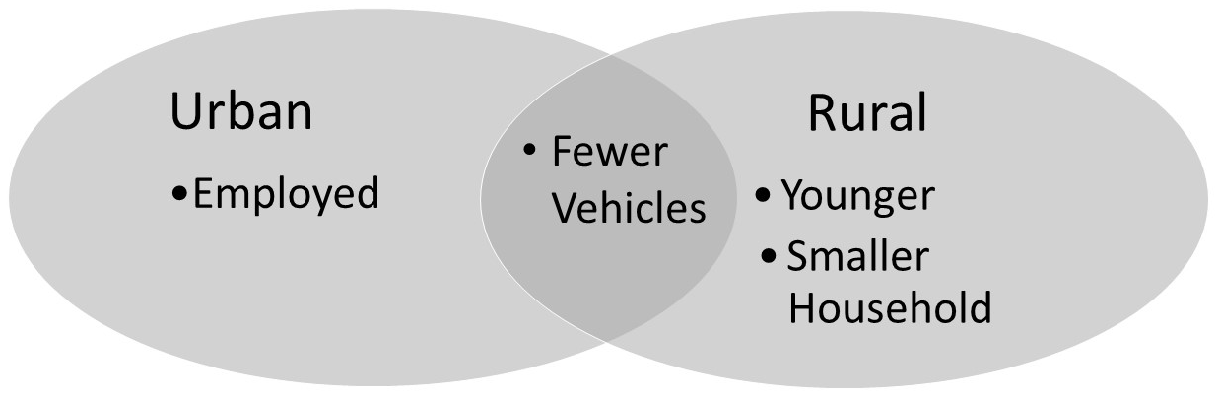
FIGURE 2 Similarities of Urban, Rural, and Nationwide Shared Transportation Bundles
Differences
As seen in Figure 3, there were several important differences in the demographic trends between the different bundles and also between urban and rural settings.
In urban areas, the trends for DR and RT were similar: younger, higher education, higher income level, and smaller household size. The DRT bundle was also similar, with the addition of males being more likely to use the bundle. The fourth bundle, BCDRT, had numerous differences. However, due to the limited sample of people who use all five modes, this mode was not found to be conclusive.
As seen in Figure 3, gender was significant for both DR and RT where males were more likely to use the bundles in rural areas. Higher education was important for all three bundles. Similarly, higher income levels were significant for the three bundles.
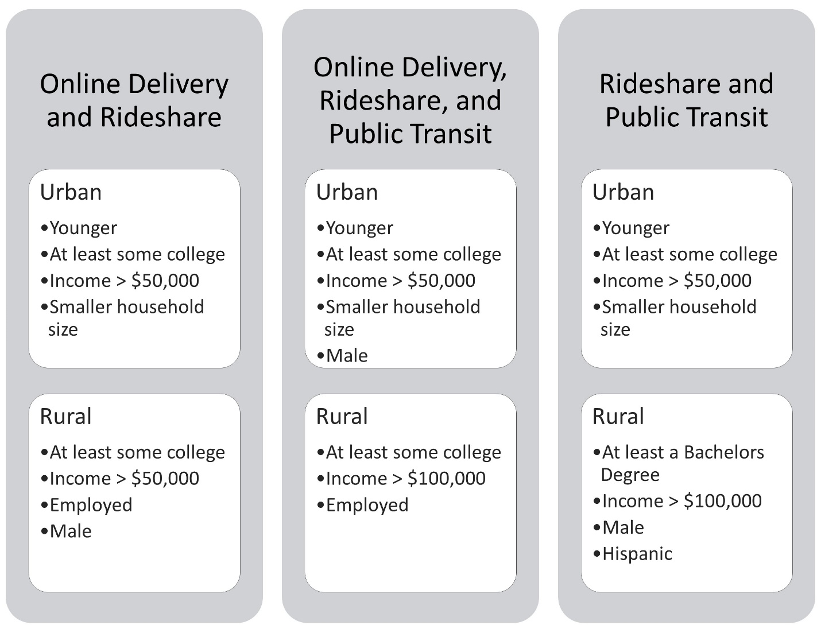
FIGURE 3 Difference between Urban and Rural Bundles
Areas for Future Research
This study has many areas for improvement and future research. A way to improve this study would be to create adjusted weights for the sample size of each bundle using NHTS data. It would also be interesting to include other micromobility modes, such as e-scooters, in potential MaaS bundles; however, but this is not included in the 2017 NHTS. Another way to improve this study would be to use questions that look at the choices between alternatives for a single point in time, as opposed to over the last thirty days. Comparing findings for MaaS in the United States to other countries with more robust research on real world implementations (such as Australia and Sweden) would be interesting as well (4-6). Another noteworthy area for future research is to look at equity of demographics groups including older populations, those with a lower education levels, those with lower incomes, those with more household vehicles, those without a job, and, typically, those in larger households. These areas of future research can continue to help understand who is willing to use MaaS and help market these services to those groups.

AUTHOR CONTRIBUTIONS
The authors confirm contribution to the paper as follows: study conception and design: C. Brakewood, C. Crossland; data collection: C. Crossland; analysis and interpretation of results: C. Crossland, C. Brakewood; draft manuscript preparation: C. Crossland, C. Brakewood. All authors reviewed the results and approved the final version of the manuscript.

REFERENCES

1. Shaheen S, Cohen A. Mobility on demand (MOD) and mobility as a service (MaaS): early understanding of shared mobility impacts and public transit partnerships. Demand for Emerging Transportation Systems: Elsevier; 2020. p. 37-59.
2. A Brief History of MaaS Global, the company behind the Whim App 2019 [Available from: https://whimapp.com/history-of-maas-global/#:~:text=The%20first%20vision%20of%20a,for%20transportation%20providers%20and%20customers.
3. Goodall W, Dovey T, Bornstein J, Bonthron B. The Rise of Mobility as a Service: Reshaping How Urbanites Get Around. Deloitte Review: Deloitte; 2017.
4. Sochor J, Karlsson IM, Strömberg H. Trying out mobility as a service: Experiences from a field trial and implications for understanding demand. Transportation Research Record. 2016; 2542(1):57-64.
5. Hoerler R, Stünzi A, Patt A, Del Duce A. What are the factors and needs promoting mobility-as-a-service? Findings from the Swiss Household Energy Demand Survey (SHEDS). European Transport Research Review. 2020; 12:1-16.
6. Ho CQ, Hensher DA, Mulley C, Wong YZ. Potential uptake and willingness-to-pay for Mobility as a Service (MaaS): A stated choice study. Transportation Research Part A: Policy and Practice. 2018; 117:302-18.
7. Shaheen S, Bansal A, Chan N, Cohen A. Mobility and the sharing economy: industry developments and early understanding of impacts. 2017. [Available from: https://escholarship.org/uc/item/96j5r729.
8. Shaheen S, Chan N. Mobility and the sharing economy: Potential to facilitate the first-and last-mile public transit connections. Built Environment. 2016; 42(4):573-88.
9. Shaheen S, Cohen A. Mobility on Demand in the United States. Analytics for the Sharing Economy: Mathematics, Engineering and Business Perspectives: Springer; 2020. p. 227-54.
10. Shaheen S, Cohen A. Mobility on Demand in the United States: From Operational Concepts and Definitions to Early Pilot Projects and Future Automation. 2020. [Available from: https://www.researchgate.net/publication/339874233_Mobility_on_Demand_in_the_United_States_From_Operational_Concepts_and_Definitions_to_Early_Pilot_Projects_and_Future_Automation.
11. Shaheen S, Cohen A, Yelchuru B, Sarkhili S, Hamilton BA. Mobility on Demand Operational Concept Report. U.S. Department of Transportation, Intelligent Transportation Systems Joint Program Office; 2017.
12. Shaheen S, Cohen A, Stocker A, Martin E. Mobility on Demand: A Smart, Sustainable, and Equitable Future. Transportation Research Circular. 2019 (E-C244).
13. Shaheen SA, Cohen A, Farrar E. Mobility on Demand: Evolving and Growing Shared Mobility in the Suburbs of Northern Virginia. Implications of Mobility as a Service (MaaS) in Urban and Rural Environments: Emerging Research and Opportunities: IGI Global; 2020. p. 125-55.
14. Shaheen S, Cohen A. Similarities and Difierences of Mobility on Demand (MOD) and Mobility as a Service (MaaS). ITE Journal. 2020; 90(6):29-35.
15. Lucken E, Frick KT, Shaheen SA. “Three Ps in a MOD:” Role for mobility on demand (MOD) public-private partnerships in public transit provision. Research in Transportation Business & Management. 2020: 100433.
16. Shaheen S, Cohen A, Martin E. US Department of Transportation’s Mobility on Demand Initiative: Moving the Economy with Innovation and Understanding. Transportation Research Circular. 2018 (E-C231).
17. Jiao J, Bischak C, Hyden S. The impact of shared mobility on trip generation behavior in the US: Findings from the 2017 National Household Travel Survey. Travel Behaviour and Society. 2020; 19:1-7.
18. Deka D, Fei D. A comparison of the personal and neighborhood characteristics associated with ridesourcing, transit use, and driving with NHTS data. Journal of Transport Geography. 2019;76:24-33.
19. Sikder S. Who Uses Ride-Hailing Services in the United States? Transportation Research Record. 2019: 15.
20. Mitra SK, Bae Y, Ritchie SG. Use of ride-hailing services among older adults in the United States. Transportation research record. 2019; 2673(3):700-10.
21. Zhang Y, Zhang Y. Associations between Public Transit Usage and Bikesharing Behaviors in The United States. Sustainability. 2018; 10(6):1868.
22. ORNL. National Household Travel Survey: Federal Highway Administration; n.d. [Available from: https://nhts.ornl.gov/.
23. Westat. 2017 NHTS Data User Guide. 2019. [Available from: https://nhts.ornl.gov/assets/NHTS2017_UsersGuide_04232019_1.pdf.
24. Westat. Main Study Retrieval Questionnaire. 2018 February 28. [Available from: https://nhts.ornl.gov/assets/2016/NHTS_Retrieval_Instrument_20180228.pdf.

